Lab Report 1
Taylor Yi, 2268278
EI Link: https://studio.edgeimpulse.com/public/948519/live
Task 1:
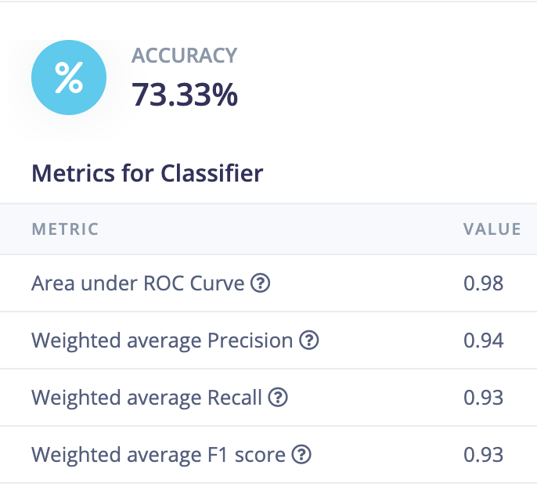
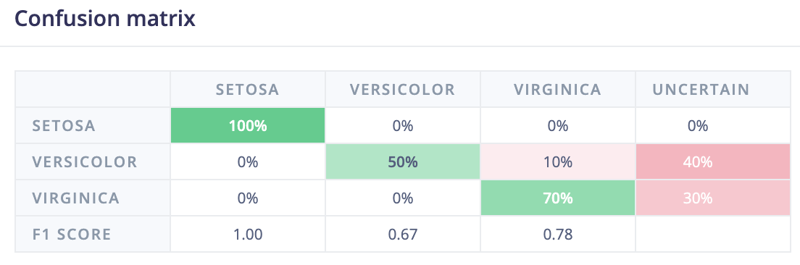

Task 2:
Dense 20 > Dense 10
